Frayer Model
Definition | Picture  Word
Examples | Nonexamples

Frayer Model: Area of Polygons
Definition | Picture  Area of Polygons
Examples | Nonexamples

Relationship to Area of Parallelograms (printable worksheet)
 | Formula | Relationship to the Area of a Parallelogram
Area of a Rectangle |  | 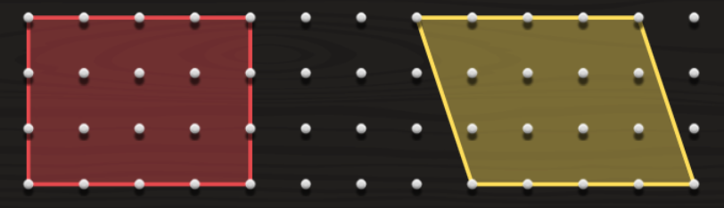
Area of a Parallelogram
Area of a Triangle |  | 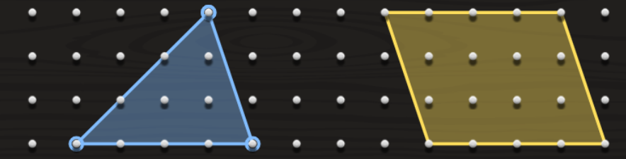
Area of a Trapezoid |  | 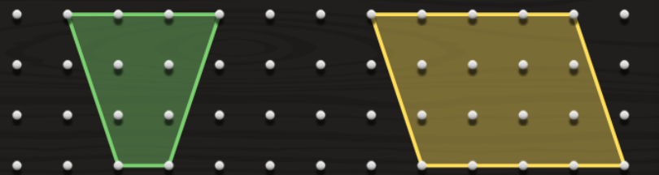
Area of a Circle |  | Circle Template

Circle and Parallelogram Activity
Follow the directions from Slides 24–39 when completing this activity. You will complete this activity independently and then submit your work and a photo of your product electronically through e-mail and/or our virtual classroom (e.g., Google Classroom, Seesaw).
- Construct a circle (either print a template, use a compass, or trace an object such as a bowl or lid to a container).
- List all the fact pairs for 360 below.
Divide the circle into an equal number of sections, using one pair of factors for 360.
- Color each half of the circle a different color. Take a picture of your circle.
- Use $A=πr^{2}$ to find the area of the circle and record your answer below.
$$A=πr^{2}$$

- Carefully cut out the individual sections of the circle.
- Arrange the sections of the circle to form a figure similar to a parallelogram.
  - What do you notice about the base of the parallelogram in relation to the original circle?
  - What do you notice about the height of the parallelogram in relation to the original circle?
- Using the relations, find the area of your parallelogram.
  - How does the area of the parallelogram you calculated compare to the area of the circle?
- Watch this video on you tube: https://www.youtube.com/watch?v=YokKp3pwVFc
- Submit this worksheet and a photo of your circle and parallelogram to your teacher by ______.

