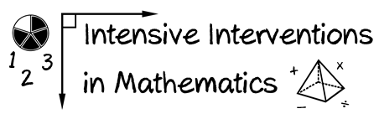



* Module 8
* Part 3
* Activity #6

**Create your plan for implementation of DBI. Fill in the DBI diagram.**

