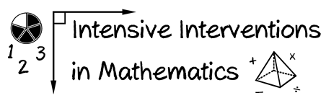
- Module 8
- Part 2
- Activity #4

List three additional ways to adapt the mathematics content with DBI. Describe why each might be helpful.

