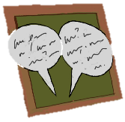
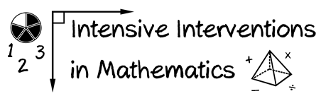
- Module 7
- Part 3
- Discussion
Make a video of yourself teaching fractions, decimals, or percentages.

Share your experience with your classmates for examples and new understanding.

Create an original post on the Discussion Board and respond to two peers.
(This space is for organizing your ideas.)

