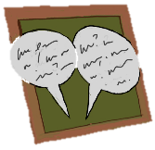
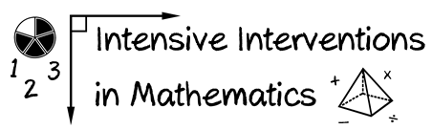
- Module 7
- Part 1
- Discussion

Share your favorite tools that you use when teaching about fractions. Describe why each tool is helpful and how you do modeling and practice with your students.

You could share a video or print materials.
(This space is for organizing your ideas.)

