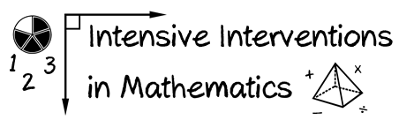
- Module 7
- Part 2
- Activity #6

Solve this problem using any part of the concrete-representational-abstract framework.
0.34 $×$ 3 =

