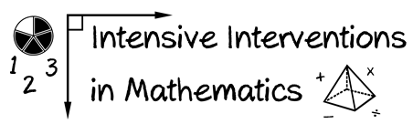
- Module 7
- Part 2
- Activity #4
- Solve the addition problem using two different fraction models.
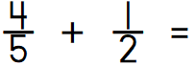

- Solve the subtraction problem using two different fraction models.
