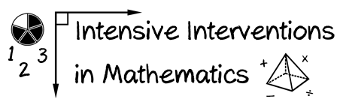
- Module 6
- Part 2
- Activity #7

Review the multiplicative schemas from the module on instructional strategies (Module 5).
How could you use two different schemas to describe this problem?
1 7
× 5

Schema 1:

Schema 2:

