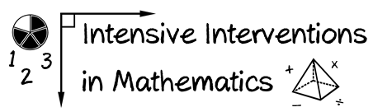
- Module 6
- Part 1
- Activity #1

Look at problem A. Describe and draw two conceptual understandings of addition.
- 5 + 6 = ____

Look at problem B. Describe and draw two conceptual understandings of subtraction.
- 8 – 3 = ____

