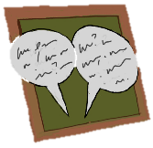
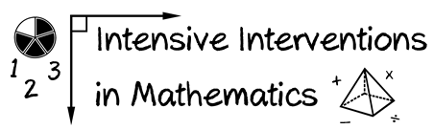
- Module 5
- Part 1
- Discussion
Share a fluency-building activity that you have used with your students. You can share a video of the activity or share the materials with other teachers.

(This space is for organizing your ideas.)

