NCII Intensive Intervention in Mathematics Module 5 Coaching Materials

 | Page | Customizable
Coach Communication Tools
Sample Email to Set up Coaching Activity | 2 | x
Sample Email to Follow-up After Coaching Activity | 3 | x
Coach and Teacher Module Implementation Packet (send to teachers as PDF)
Coach and Teacher Master Checklist | 4
Teaching Word Problem Solving Coaching Discussion Guide | 5
Discussion Fidelity Checklists (Optional) | 7 | x
Appendix A: Classroom Application  (Preparing to Teach Word Problems) | 8
Appendix B: Attack Strategies | 9
Appendix C: Schemas | 10

Sample Email to set up Module 5 Coaching Activities (all teachers)

Dear Teachers,

Our next coaching interaction for the course will be on explicit instruction in mathematics with a focus on problem solving and how to build on these strategies to help students solve word problems using attack strategies and schemas.

The coaching observation and debrief for Module 5 will take place during the weeks of DATES. The observation should be a lesson when you are teaching specific instructional strategies for solving word problems. To prepare for the observation and debrief, please complete the classroom application (see Appendix A). After you’ve completed the classroom application, prepare a word problem solving lesson for me to observe the attack strategy and/or schema(s).
- Attack strategy
- Schema(s)

For the observation, I will observe the attack strategy and/or schema(s) associated with the word problems you selected. Attached, please find a coaching packet for Module 5. I also want to remind you that our conversations are completely confidential and non-evaluative. If you have any questions, please feel free to contact me.
I’m looking forward to seeing you for the Module 5 coaching activity!

Best,

COACH NAME

General tips:
- Include personal greeting
- Share “big picture focus” of Module 5 coaching activity and the steps to complete
- Establish timeframe for communication and next steps
- Remind teachers about confidentiality and non-evaluative nature of pilot
- Attach Coach and Teacher Module Implementation Packet
- Indicate openness and availability for questions

Sample Post-Coaching Interaction Discussion (individual teachers)

Dear Teacher A,

It was great to talk with you about your recent lesson with a focus on problem solving, and how to build on these strategies to help students solve word problems by teaching schemas and attack strategies. I really appreciate your thoughtful reflection on XXXXX. As we discussed, you might consider integrating more XXXXXX.

Best,

COACH NAME

General tips:

- Thank teachers for their time
- Include a personal comment re: classroom, student, context
- If requested, include notes from discussion
- Include a praise point in line with module expectations
- Reference an implication for practice identified during the debrief
- Close with expectations about the next coaching activity

Coach and Teacher Master Checklist: Module 5
 | Coach | Teacher
Pre-discussion | Email the teacher to share expectations and resources for discussion and to request schedule.  Schedule discussions.  Remind the teachers that what is discussed is completely confidential and non-evaluative  Provide classroom teacher with a copy of the coaching materials.  Review attack strategies (Appendix B) and Schemas (Appendix C). | Enact an intensive intervention mathematics lesson for word problem solving for your coach to observe.  Direct any questions about the discussion content to coach.  Review attack strategies (Appendix B) and schemas (Appendix C).
During discussion | Use the Teaching Word Problem Solving: Coaching Discussion Guide to guide a discussion about the word problem lesson. | During the debrief, use the Teaching Word Problem Solving: Coaching Discussion Guide, to share your thoughts and ideas with your coach.
Post-observation | Send a follow-up email to recap the discussion.  Share a copy of the completed: Teaching Word Problem Solving: Coaching Discussion Guide, if requested, with the teacher to recap notes and next steps. | Integrate key takeaways from lesson observation and debrief discussion.  Reach out to your coach with any questions.

Teaching Word Problem Solving: Coaching Discussion Guide
Teacher: | Date: | Duration of conversation:

Note to coaches: Below, please find an overview of activities and questions to consider. The focus of the conversation will be based on the needs of the teacher and may vary. Note: teachers will select an attack strategy or schema(s) to teach.
Observation focus:
- Attack strategy (See Appendix B)
- Schema(s) (See Appendix C)
Activity | Discussed? (Mark with x) | Notes
Discuss how you identified and selected the word problems for the lesson.

Questions to consider:
Describe why you selected the word problems.
Are the word problems you selected connected to high-stakes assessments for students?

(Option 1) Review and discuss the attack strategy you taught (e.g., RIDGES, R-CUBES, RIDE, STAR)

Prompt/questions to consider:
Did students have previous experience with the attack strategy?
Discuss why you selected this particular attack strategy.
What scaffold(s) might you use to support student use of the attack strategy (e.g., anchor chart, checklist)?
Were there any steps of the attack strategy that need reteaching?

Supporting document: Appendix B
(Option 2) Review and discuss how you taught the schema(s) (e.g., change decrease, total, difference, equal groups).
Questions to consider:
How did you use explicit instruction to model and practice the schema(s)?
Discuss the equation or graphic organizer selected and how it supported the schema.
Was the selected equation or graphic organizer successful? Why? Why not?

Supporting document: Appendix C
Identify implications for practice from selecting word problems and teaching an attack strategy or schema(s).

Questions to consider:
What is an implication for your practice from the process of teaching the attack strategy and/or schema(s)?
What adjustment might you make in future lessons? Discuss as applicable:
- Avoiding key words directly tied to operations
- Using concise and precise language
- Linking to math concepts; going beyond teaching math procedures
- Providing sufficient opportunities to practice word problems

Coaching Discussion Fidelity Form: Module 5 Classroom Application (Optional)

Note: This form is not evaluative of teacher performance. This protocol is used to measure the instructional coach’s fidelity to the procedures for debriefing the observation and track the components of the debrief sessions conducted.

Teacher:
Discussion date: | Duration of discussion:

Word Problem Selection | Yes | No | Notes/Reflections
Teacher indicated why the word problems were selected. | 1 | 0
Teacher indicated whether the word problems were connected to high-stakes assessments for students. | 1 | 0
Attack Strategy | Yes | No
Teacher reflected on students’ previous experience with attack strategy selected. | 1 | 0
Teacher discussed why attack strategy was selected. | 1 | 0
Teacher indicated possible scaffolds to support use of the attack strategy. | 1 | 0
Teacher identified areas of the attack strategy for reteaching. | 1 | 0
Schema(s) | Yes | No
Teacher discussed the equation or graphic organizer selected and how it supports the schema(s). | 1 | 0
Teacher discussed whether or not the equation or graphic organizer was successful. | 1 | 0
Identify Implications for Practice | Yes | No
Actionable implication(s) for practice were identified. | 1 | 0 | Example of implication for practice:
Adjustment(s) were identified for future lessons. | 1 | 0 | Example of adjustment(s) for future lessons:

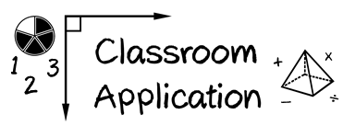
Appendix A

Module 5

(1) Identify the word problems that your students will be asked to solve on high-stakes assessments.

(2) Teach an attack strategy.

(3) Teach the schemas.

Appendix B: Attack Strategies

UPSC or UPSCheck
Understand.
Plan.
Solve.
Check.

R-CUBES
Read the problem.
Circle key numbers.
Underline the question.
Box action words.
Evaluate steps.
Solve and check.

RIDGES
Read the problem.
I know statement.
Draw a picture.
Goal statement.
Equation development.
Solve the equation.

RIDE
Read the problem.
Identify the relevant information.
Determine the operation and unit for the answer.
Enter the correct numbers and calculate, then check the answer.

STAR
Stop and read the problem carefully.
Think about your plan and the strategy you will use.
Act. Follow your plan and solve the problem.
Review your answer.

RICE
Read and record the problem.
Illustrate your thinking.
Compute.
Explain your thinking.

SUPER
Slowly read the story problem twice.
Underline the question and circle the numbers your need.
Picture it! Draw the scenario to show what is happening.
Explain the problem with a number sentence.
Rewrite the answer in a sentence.

SHINE
Slowly and carefully read the problem.
Highlight or underline key information.
Identify the question by drawing a circle around it.
Now, solve the problem with numbers, pictures, and words. Show your work.
Examine your work for precision, accuracy, and clarity.
Share your answer by writing a sentence.

SIGNS
Survey questions.
Identify key words.
Graphically draw problem.
Note operations.
Solve and check.

SOLVE
Study the problem.
Organize the facts.
Line up the plan.
Verify the plan with computation.
Examine the answer.

Appendix B: Schemas

Additive Schemas
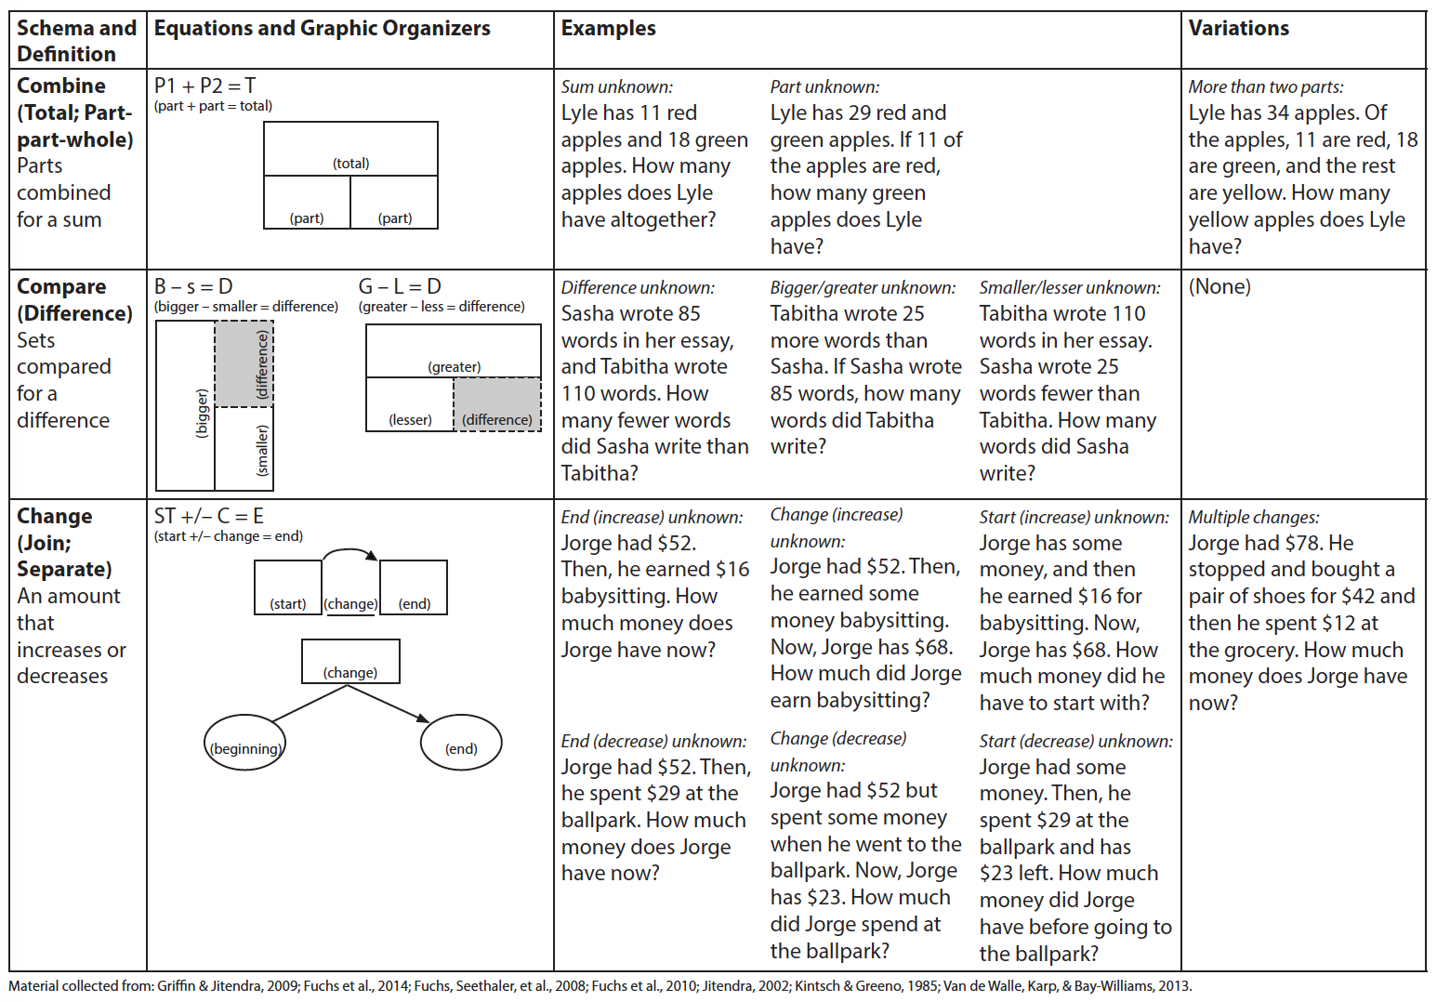

Figure from Powell & Fuchs (2018) Teaching Exceptional Children.

Multiplicative Schemas
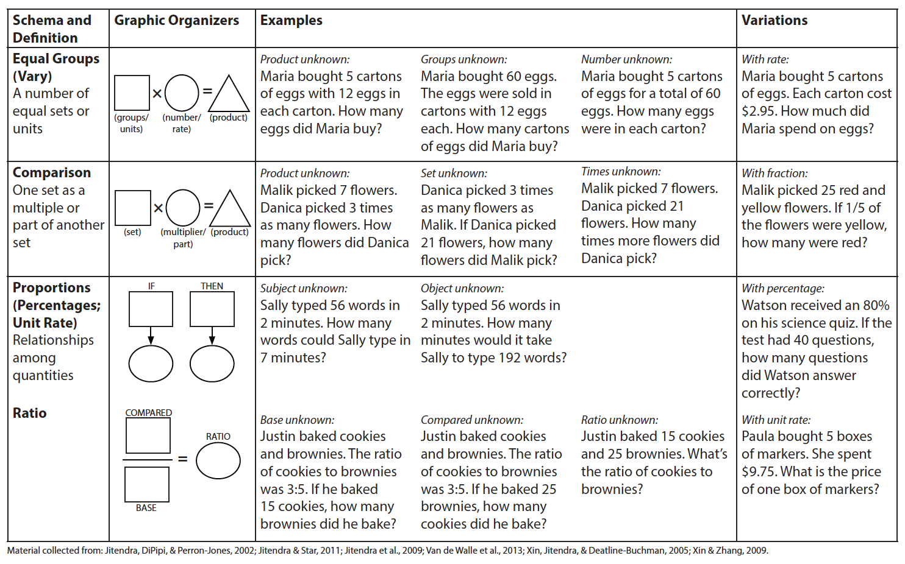

Figure from Powell & Fuchs (2018) Teaching Exceptional Children.

