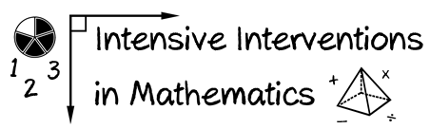
- Module 5
- Part 2
- Activity #4
Look at several problems.
- Identify the key words used within each of the problems.
- Describe how teaching students to identify these key words may be problematic.

- What are the key word(s)?

- Why would teaching these key words be problematic?

Smarter Balanced third-grade release item (2013)
  - What are the key word(s)?

  - Why would teaching these key words be problematic?

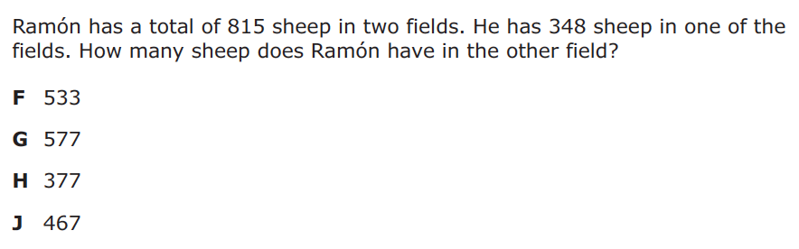

STAAR third-grade release item (2014)
- What are the key word(s)?

- Why would teaching these key words be problematic?

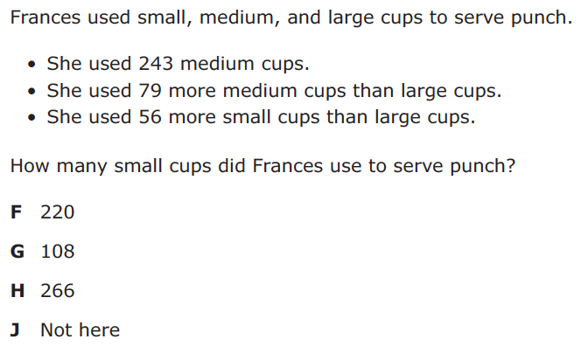

STAAR fifth-grade release item (2014)
- What are the key word(s)?

- Why would teaching these key words be problematic?

