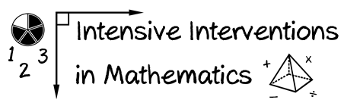
- Module 5
- Part 1
- Activity #2
Look at this student’s answers to a multiplication test.
Which facts would you select for Incremental Rehearsal? (Circle them.)
