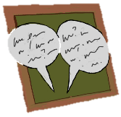
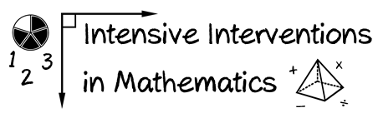
- Module 4
- Part 2
- Discussion

Describe three manipulatives or representations that you use on a regular basis. Describe the pros and cons of each.

(This space is for organizing your ideas.)

