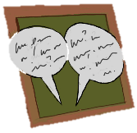
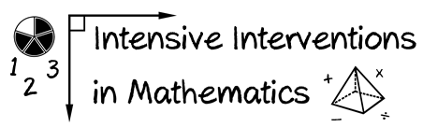
- Module 4
- Part 1
- Discussion

Share a video of your explicit instruction and receive feedback on your modeling, practice, and supporting practices.
(This space is for organizing your ideas.)

