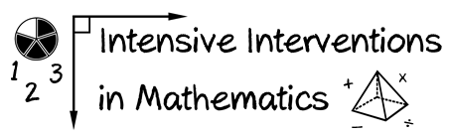

* Module 4
* Part 3
* Activity #9

**Look at this intensive intervention lesson about word problems.**

* **Identify five instances where the mathematical language is *preci*se.**
* **Identify five instances where the mathematical language is *concise*.**

**buccaneer problems: Let's review. what's a total problem? When parts are put together into a total. in a total problem, two parts are put together to make a total. all total problems have the same total equation. whats the total equation? P1 + P2 = T. When we solve word problems, what two things do we have in our answer? a number and a label. Very good. You must have a number and a label. What is a label? A word that tells us about our missing information. Excellent. A label is a word that tells us about our missing information. now let's practice solving word problems. Today, we'll learn a new type of problem. We call these difference problems. Difference means the difference between two amounts. in a difference problem, you compare two amounts. When you compare you put two amounts side by side to see which amount is greater and which amount is less. You compare two numbers and find the difference between the amount that's greater and the amount that's less. **

**Amy is than john. The difference between amy and john is this much. Point to the difference in heights. When we compare amy and john, this is the difference between their heights. who is taller? amy. That's right. Amy is taller. Who is shorter? John. Right. When we compare how tall they are, amy is taller. john is shorter. When yo ucompare two things, like people, or two amounts of something, one amount is greaterm and one amount is less. In difference problems, our job is to figure how much greater/taller or less/smaller one amount is compared to the other amount. look up here. let me show you another example. point to the difference picture. This box is the amount that's greater (point and trace around entire G Box.) it's like amy (write amys name in the greater box). this box is the amount that's less (point and trace around the entire l box). It's like john (write john's name in the less box). This is the difference between amy and john (point and trace around the box with the dotted line.) In difference problems, we compare two amounts to find the difference. one thing is greater. the other thing is less. To find the difference, we subtract. what signs do we use in subtraction number sentences? A minus and an equal sign. That's right. to find the difference, we subtract. in our difference equation, we use a minus sign and an equal sign. Let's think back to total problems. in total problems, we put parts together into a total. what signs do we use in our total equation. p1 plus p2 equals t?**

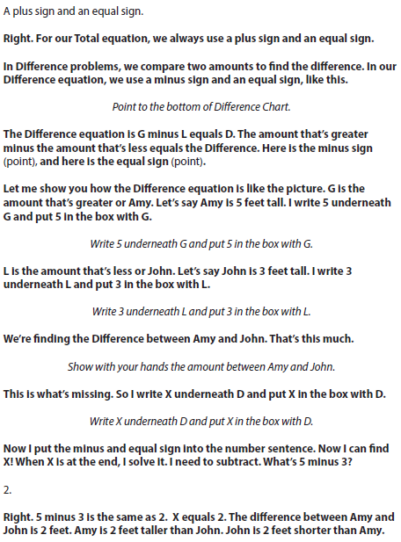

**Complete the table.**

* **Identify five instances where the mathematical language is *preci*se.**
* **Identify five instances where the mathematical language is *concise*.**

|  |  |
| --- | --- |
|  | **Examples of Language from Intensive Intervention** |
| **Precise** | **1.** |
| **2.** |
| **3.** |
| **4.** |
| **5.** |
| **Concise** | **1.** |
| **2.** |
| **3.** |
| **4.** |
| **5.** |