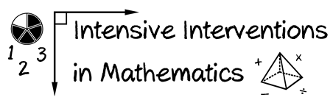
- Module 4
- Part 3
- Activity #8

Fill in the chart with your own “Instead of…say…” for each of the mathematics strands.

 | Instead of… | Say…
Numbers and Operations
Algebra
Geometry
Measurement
Data Analysis

