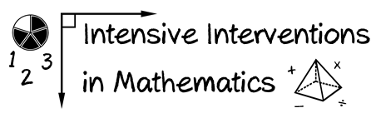
- Module 4
- Part 2
- Activity #7

Watch Asher solve 6 + 8.

- Describe two concrete activities you could use to help Asher solve the problem correctly.

- Describe two representational activities you could use to help Asher solve the problem correctly. Draw them.

- Describe one abstract activity for helping Asher solve the problem correctly.

