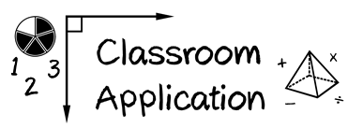

Module 3

Evaluate a current instructional intervention or strategy. What is the evidence?

In Part 2 of this Module, you wrote a reflection on the evidence-based practices you are currently using in your classroom and how you knew of their evidence base. Now take this a step further: examine your go-to intervention or strategy closely. Look at the evidence. Determine whether to continue that practice, or to replace/supplement it.

Name of Practice | Assessment Data to Show Results |  | Replication |  |  | Setting
 | Improvement from Before Intervention | Improvement Compared to No Treatment Students | Multiple Researchers | Multiple Students | Multiple Times | Setting and Students Similar to Your Own?
Continue to Use?  YES NO | Replace With |  |  | Supplement With
Continue to Use?  YES NO | Replace With |  |  | Supplement With

