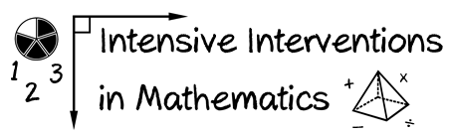
- Module 3
- Part 2
- Activity #3
Locate a Tier 2 evidence-based practice in mathematics for a 4th-grade student.

Compare sites on:
Evidence-based practice to compare across sites:
- Ease of locating information
- Quality of information
- Pros and cons of the site

Site Name and Web Address | Site Characteristics | Notes
What Works Clearinghouse  https://ies.ed.gov/ncee/wwc/ | Ease of Locating Information
 | Quality of Information
 | Pros of Site
 | Cons of Site
Evidence for ESSA  https://www.evidenceforessa.org/ | Ease of Locating Information
 | Quality of Information
 | Pros of Site
 | Cons of Site
Teaching LD  http://teachingld.org/ | Ease of Locating Information
 | Quality of Information
 | Pros of Site
 | Cons of Site

Evidence Based Intervention Network  http://ebi.missouri.edu/ | Ease of Locating Information
 | Quality of Information
 | Pros of Site
 | Cons of Site
National Center on Intensive Intervention  http://www.intensiveintervention.org/ | Ease of Locating Information
 | Quality of Information
 | Pros of Site
 | Cons of Site
Another site you currently use: | Ease of Locating Information
 | Quality of Information
 | Pros of Site
 | Cons of Site
Another site you currently use: | Ease of Locating Information
 | Quality of Information
 | Pros of Site
 | Cons of Site

