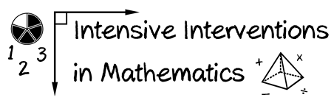
- Module 2
- Part 2
- Activity #7
Visit the Academic Progress Monitoring Tools Chart.
Note: In the video/presentation, Dr. Powell refers to an older version of the tools chart than is currently available on the NCII website. We’ve updated this activity so that the content discussed in the video/presentation aligns with the language on new tools chart.
- Fill in the table for the mathematics measures available for the grade levels you teach.
- Consider the Psychometrics of the measures
- Consider the use for Progress Monitoring.
- Consider the use for Data-based Individualization.

Measure | Psychometrics |  | Progress Monitoring |  | Data-based Individualization
Category referred to in the video/presentation | Reliable | Valid | Alternate Forms | Sensitive to Improvement | Change Instruction | Increase Goals | Teacher Planning
Where to locate the information on the new tools chart | “Performance Level Standards” Tab |  | “Growth Standards” Tab  *note that sensitivity is now included for both reliability and validity of the slope |  |  |  | “Usability” Tab
Notes/Comments:

