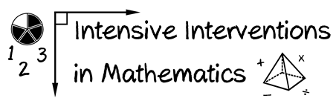
- Module 2
- Part 1
- Activity #3
You will conduct a survey of the assessments available at your school.

Fill in the table about your current formative, diagnostic, and summative assessments.

Then, fill in your assessment needs for DBI.

Assessments We Have
Assessment Name | Formative | Diagnostic | Summative | Helpful for DBI?

Assessments We Need
Assessment Name | Formative | Diagnostic | Summative | Helpful for DBI?

Notes/Comments:

