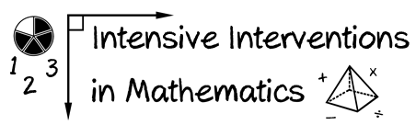
- Module 1
- Part 1
- Journal Entry

Provide a rationale for the need for early intensive intervention by pretending that you’re trying to convince a district administrator of the need for the DBI process.
(This space is for organizing your ideas.)

