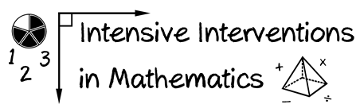
With your coach: Identify and map the foundational mathematics skills that you may include within intensive intervention.

Module 1
- Consider the following:
  - the grade level(s) you teach
  - your state’s core standards
  - your students’ present skill levels
  - appropriate sequencing of skills
Student(s) | Current Level | Skills to Teach/Reteach | Standard to Meet

Module 1
(cont.)

Student(s) | Current Level | Skills to Teach/Reteach | Standard to Meet

