Activity 6.24 – Analyze a Curriculum Example
Apply your Knowledge
Workbook
Curriculum Example
Point to the title of the story. The name of this story is A Shadow. The word shadow has two parts, so it is a two-syllable word. Listen for the two syllables in this word. Pause between syllables, shad ow.

To complete this lesson (above) using explicit instruction, how would you elicit responses? You can use these words as examples: shut ting show down shat ter shush es shal low
The beginning sound in the word shadow is /sh/. Listen for the /sh/ sound in the beginning of this word: shadow.
Look at me. Wait until all the students look at you.
Listen to each word I say. If you hear the /sh/ sound in the word, put your thumb up. If you do not hear the /sh/ sound, put your thumb down.
Listen: shine. Do you hear a /sh/ in shine? Yes, you hear /sh/ in shine.
Listen: some. Do you hear /sh/ in some? No, you do not hear /sh/ in some.
Continue in the same manner with these words: shake, choose, mashes, fizzes

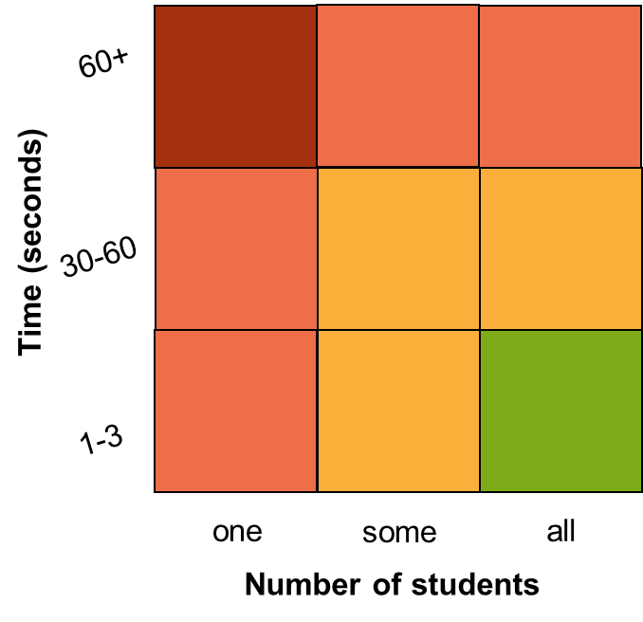
What is the method used to elicit responses?

How well does it maximize student engagement?

