Don't Panic, Pivot! Tips for Implementing Data-Based Individualization (DBI) for the Synchronous and Asynchronous Learner

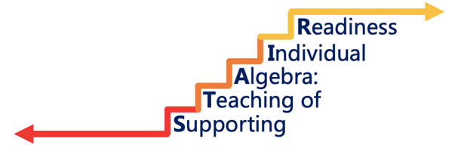

Project STAIR
Data Based Individualization Webinar: Facilitator’s Guide

October 2020

Funded by the Office of Special Education Programs of the U.S. Department of Education, #H326M170006

Data Based Individualization Webinar: Facilitator’s Guide

A: Overarching Goal
This session is designed to provide participants with an understanding of the data-based individualization (DBI) model when used to support algebra readiness in the middle school classroom.

B: Key Understandings
Participants will have a working understanding of how to use Data Based Individualization in the virtual environment.

C: Session Objectives
- Understand Data Based Individualization and its relevance to algebraic readiness.
- Understand key components of the model and how to deploy it.
- Understand key components of deploying the model in the virtual environment.

Session at a glance

TIMING | ACTIVITY | DESCRIPTION
:00 | Introduction and overview | Dr Erica Lembke (University of Missouri) will give an overview of the project, describing the goals of project STAIR and its use of DBI.
:20 | Overview, Assumptions, and DBI ‘Check in’ | Stephanie Hopkins (University of Missouri) will give an in-depth description of Data Based Individualization (DBI) and review key points of the model.
:30 | Strategies in the classroom | Stacy Hirt (University of Missouri) will focus on the strategies that have been part of the project for in person learning.
:40 | Strategies for the virtual learner | Alain Mota (Southern Methodist University) will discuss some of the main components to consider as DBI transitions to the remote learning environment.

Introduction and Overview  20 min | *prior to session disseminate infographic to participants  Attendees will be welcomed to the session. The purpose of the session will be stated. There will be a recap of the specifics of the project.  There will be a review of the Data Based Individualization (DBI) model: the key pillars of the professional development will provide teachers tools to enhance the students’ algebraic readiness. The tools include explicit instruction; utilizing problem solving structures; visual representation and fluency building on math; and assessment procedures that include screening, diagnostic assessment, and progress monitoring.  The professional development and the coaching model will both be discussed during this section.
Overview, Assumptions and the DBI model  10 min | There will be a specific description of Data Based Individualization (DBI). The model schematic will be shown and explained.  There will be a comparison to illustrate what DBI is and is not. Emphasis will be given on the key components of DBI.  The reasoning behind the use of DBI will be discussed and some practitioners’ project quotes will be shared to illustrate key takeaways.  There will be a discussion of data and how it is used with DBI to address the needs of specific learners. These learners are students for whom core instruction and/or supplemental intervention is not sufficient. These students are identified as students in need of specialized instruction or Tier 3 instruction within an RTI model. DBI is intended for students who require intensive individualized instruction.
In Person strategies to Support DBI  10 min | Specifics of when to use DBI strategies will be discussed.  A team of teachers and interventionists should utilize the DBI framework to determine when a change should be made in instruction, figure out how to make that change, develop a plan that matches the student needs, and continue to collect data to see if the changes are working.  The seven dimensions of the intensification taxonomy and its relevance to DBI will be explained and examples will be used to illustrate each of the dimensions.  Each of the dimensions will have a specific example.
The virtual environment  10 min | There will be 5 main points discussed in the webinar that engage the virtual environment: building community, understanding the workspace, promoting interactive activities during synchronous time, understanding learner focus during asynchronous time, and engaging in dynamic mutual feedback.  Each of the components will also have an example of platforms or apps used by practitioners in the field.  The session will end by opening the floor to questions.

