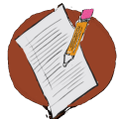

Activity 2.1 – Stop & Jot
Your Examples of Setting Events
Workbook

Develop an example of a student with whom you’ve worked who exhibits problematic behaviors that are affected by a setting event.

________________________________________________________________________________________________________________________________________________________________________________________________________________________________________________________________________
Include information about the behaviors and context (ABCs).

________________________________________________________________________________________________________________________________________________________________________________________________________________________________________________________________________

