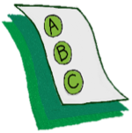
Activity 1.7 – Quiz
Observable and Measurable?
Workbook

Look at the list below. Circle the items that are observable and measurable.

- Gets out of desk and hits another student.

- Has school phobia.

- Spacey

- Reads 120 wpm.

- Says she hears voices.

- Emotionally disturbed

- Doesn’t like classmates

