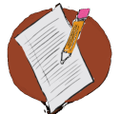
Activity 4.3 – Stop & Jot
Script Behavior Specific Praise Statements
Workbook

- Write three (or more) specific praise statements that you will use in your classroom to recognize appropriate social behavior.
- Also, consider how you would modify these based on students’ learning histories, age, etc.

Specific Praise Statement | Possible Modifications

