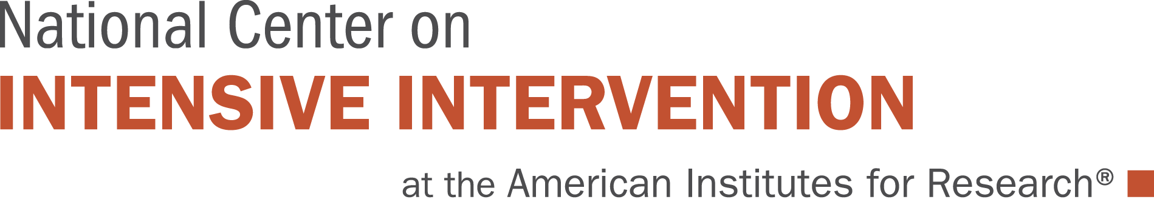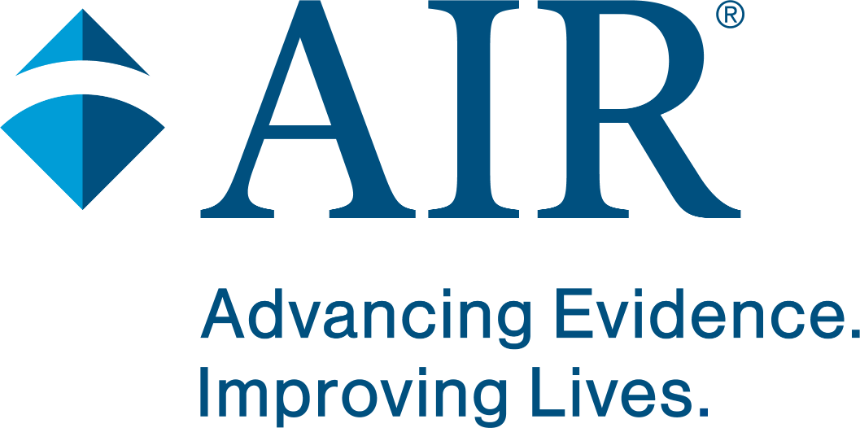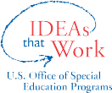

Capacity Assessment for Intensive Intervention Institute (SEA Strand)
Agency: Date:

Directions: This tool measures key components of state capacity to support implementation of data-based individualization (DBI). This assessment can be completed by an individual or team. To complete this assessment, please choose a rating score. During the institute, we will dig deeper into each of these sections and you will record your agency’s strengths in each of these areas, and identify areas for improvement.

Domain 1: Alignment1

Contextual fit and overlap of DBI within the SEA’s or LEA’s current initiatives and work.

Key Personnel: Refers to personnel involved with making decisions around DBI and implementation. They include those with decision making authority, a team to lead the initiatives, and two-way communication.

Fit: Describes the extent to which DBI aligns with existing initiatives and structures. Fit should be considered within the context of current and future initiatives, common language, and the organizational structure of the SEA (e.g., personnel, offices, training, and TA delivery system).

Indicator

Key Personnel
Staff supporting DBI implementation have:
- A commitment to DBI.
- Dedicated time for implementation.
- Decision-making authority.
- Support from senior leaders (e.g., superintendent, chief).
Rating: Choose an item.
(1 = Not Present, 3 = Partially Implemented, 5 = Fully Implemented)

Why that rating?

Fit
State/district has:
- Defined priorities within and across departments to support common goals.
- Aligned initiatives across academics and behavior to achieve outcomes for students who receive intensive intervention.
- An established technical assistance delivery system (e.g., training, coaching, and professional development).
Rating: Choose an item.
(1 = Not Present, 3 = Partially Implemented, 5 = Fully Implemented)

Why that rating?

Domain 2: Internal Capacity

The ability of the SEA/LEA to self-sufficiently scale up and support DBI.

Knowledge: Refers to the current understanding of DBI and its components among those within the SEA/LEA, including expertise and experience with DBI. For knowledge, SEAs/LEAs can consider general training for all personnel at the SEA/LEA and the ability to provide specific training to coaches and/or districts/schools.

Resource Allocation: Refers to resources available to support DBI, including fiscal, material, and people. SEAs/LEAs can consider the extent to which they have the capacity to train and/or coaches LEAs or school sites, the restructuring of roles to do so, and the ability to train school teams. SEAs/LEAs can examine funding streams to blend, braid, reallocate, and/or secure new resources or funding.

Indicator

Knowledge
State/district staff has:
- Foundational DBI knowledge among key staff.
- Specialized knowledge among some staff (e.g., job-embedded coaching).
- Implementation science knowledge (e.g., stages of implementation, supporting long-term, systemic change).
Rating: Choose an item.
(1 = Not Present, 3 = Partially Implemented, 5 = Fully Implemented)

Why that rating?:

Indicator

Resource Allocation
State/district has:
- Sufficient personnel to support implementation (e.g., full-time equivalent).
- Resources to support, evaluate, and scale DBI (e.g., learning management system, database).
- Resources demonstrating sustained investment in DBI (e.g., funding).
Rating: Choose an item.
(1 = Not Present, 3 = Partially Implemented, 5 = Fully Implemented)

Why that rating?

Domain 3: Implementation

The active process of supporting LEAs or school sites with accurate and consistent implementation of DBI to support students.

Training and Coaching: Refers to the technical assistance delivery system to provide training and coaching to LEAs on implementation of DBI. SEAs/LEAs should consider their method of training and scale up, such as a pilot program, virtual training options, and/or direct TA. SEAs/LEAs will also want to gather information on lessons learned from TA delivery and incorporate those lessons into future scale up.

Data-Based Decision Making: Implementation requires the gathering of implementation/fidelity and impact/outcome data to fully evaluate their training and coaching efforts. In addition, SEAs/LEAs should consider data literacy among their staff and their trainees.

Indicator

Training and Coaching
The SEA/LEA has a professional development system for implementation site(s) that provides:
- Training.
- Coaching.
- A plan for scaling DBI.
Rating: Choose an item.
(1 = Not Present, 3 = Partially Implemented, 5 = Fully Implemented)

Why that rating?

Data-Based Decision Making
The SEA/LEA has:
- Systems to gather data on fidelity of implementation efforts.
- Systems to gather data on outcomes or impact of implementation efforts.
- Data-based processes used by key personnel to make decisions.
Rating: Choose an item.
(1 = Not Present, 3 = Partially Implemented, 5 = Fully Implemented)

Why that rating?

1The domains were adapted from McInerney, M., Zumeta, R. O., Gandhi, A. G., & Gersten, R. (2014). Building and sustaining complex systems: Addressing common challenges to implementing intensive intervention. Teaching Exceptional Children, 46, 54-63.

This resource was produced under U.S. Department of Education, Office of Special Education Programs, Award No. H326Q210001. Celia Rosenquist serves as the project officer. The views expressed herein do not necessarily represent the positions or policies of the U.S. Department of Education. No official endorsement by the U.S. Department of Education of any product, commodity, service or enterprise mentioned in this document is intended or should be inferred.

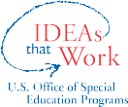

Reviewing State Capacity
Use the table below to capture your thoughts around each factor.
Factor Notes Strengths Areas for Improvement

Key Personnel
Fit
Knowledge
Resource Allocation
Training, Coaching
Data-Based Decision Making

Definitions and Considerations:
Alignment: The contextual fit and overlap of data-based individualization (DBI) within the state education agency’s (SEA’s) current initiatives and work.
Key personnel. Personnel involved with making decisions regarding DBI and implementation. They include those with decision-making authority, a team to lead the initiatives, and two-way communication.
Fit. The extent to which DBI fits within existing initiatives and structures. DBI can be considered to fit in terms of current and future initiatives, a common language, and the organizational structure of the SEA (e.g., personnel, offices, training and technical assistance delivery system).
Internal capacity: The ability of the SEA to self-sufficiently scale up and support DBI.
Knowledge. The current knowledge or understanding of DBI across the department, including expertise and experience with DBI (i.e., internal knowledge or knowledge of team and agency). For knowledge, SEAs can consider general trainings for all personnel at the SEA and the ability to provide specific trainings to coaches and/or districts/schools.
Resource allocation. The tangible resources to support DBI, including fiscal, material, and people. SEAs can consider who can train and/or coach schools, the restructuring of roles to do so, and the ability to train school teams. SEAs can examine funding streams to blend, braid, reallocate, and/or secure new resources or funding.
Implementation: The active process of supporting local education agencies (LEAs) with accurate and consistent implementation of DBI to support students.
Training and coaching. The technical assistance delivery system to provide training and coaching to LEAs on the implementation of DBI. SEAs can consider their method of training and scale-up, such as a pilot program, virtual training options, and/or direct technical assistance. SEAs also will want to gather information on lessons learned from technical assistance delivery and incorporate those lessons into future scale-up.
Data-based decision making. Implementation requires the gathering of implementation/fidelity and impact/outcome data to fully evaluate SEAs’ training and coaching efforts. In addition, SEAs will want to consider data literacy among their staff and trainees.




National Center on Intensive Intervention
3
25008_05/24

Next Steps
Identify key components for improvement in your state capacity to support LEAs to implement DBI. Identify next steps you/your team can take to address the identified areas for improvement

State Capacity Area for Improvement Next Steps
1.
2.
3.

This resource was produced under the U.S. Department of Education, Office of Special Education Programs, Award No. H326Q210001. Celia Rosenquist serves as the project officer. The views expressed herein do not necessarily represent the positions or policies of the U.S. Department of Education. No official endorsement by the U.S. Department of Education of any product, commodity, service, or enterprise mentioned in this document is intended or should be inferred.

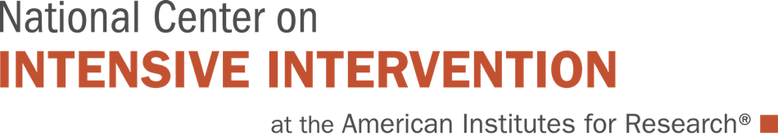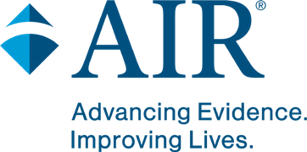

Recommendations for Building State Education Agency Capacity to Support Implementation of Data-Based Individualization
State education agencies (SEAs) have an important role in initiating, supporting, and sustaining district- and school-level implementation of intensive intervention for students with severe and persistent learning and behavior needs. Starting in 2016, the National Center on Intensive Intervention (NCII) partnered with SEAs to build their capacity to implement data-based individualization (DBI), NCII’s approach to intensive intervention. In September 2021, NCII brought together SEA personnel participating in NCII intensive technical assistance to identify recommendations for building SEA capacity to implement DBI. This document outlines five recommendations offered by SEA personnel who successfully led DBI capacity-building efforts in their states. More information about the participating SEAs and their state implementation stories is on the NCII website.
The following table presents five recommendations for building SEA capacity to implement DBI. Each recommendation includes the following components:
- Tips for successful implementation based on lessons learned from participating SEA personnel
- Examples from SEAs highlighting how the recommendations were executed in the participating states

Tips and Examples for Building SEA Capacity

Recommendation Tips for successful implementation Examples from SEAs implementing DBI

  - Develop a common understanding and shared goals for DBI implementation at the SEA.

  - Align DBI with other initiatives at the SEA.
- Conduct knowledge-building activities (e.g., training or self-study) to ensure that personnel understand DBI prior to implementation with local education agencies (LEAs).
- Engage stakeholders to create a common vision for DBI implementation.
- Anticipate and plan for turnover by developing an implementation plan that includes strategies for supporting new staff as they build DBI knowledge and implementation capacity.
- Analyze how DBI fits with existing initiatives (e.g., conduct an initiative inventory or crosswalk of DBI with existing multitiered systems of support [MTSS] and special education resources to identify similarities and differences).
- Involve personnel from multiple SEA offices who are leading related initiatives and ensure that special education personnel are involved with any SEA DBI initiative.
- Align DBI terminology and language across other state initiatives (e.g., MTSS, SSIP, dyslexia legislation, and school improvement).
- Texas, Washington, South Carolina, and Oregon participated in a baseline DBI knowledge assessment and subsequent DBI trainings to build foundational DBI knowledge and a common language.
- North Carolina established a vision for DBI that focused on closing student achievement gaps to promote equity and communicated this vision to key stakeholders.
- Texas learned that planning for sustainability was essential to ensure that DBI professional learning and guidance would continue when personnel leave and new staff are hired.
- Colorado conducted an inventory of problem-solving initiatives and collaborated across the Office of Learning Supports and the Exceptional Student Services Unit to create a DBI training series.
- Michigan aligned DBI implementation across statewide initiatives, including the State Systemic Improvement Plan (SSIP), MTSS technical assistance, and statewide literacy and dyslexia guidance.
- Rhode Island developed common language and terminology across three state initiatives that each focused on DBI and operationalized DBI within the state’s ongoing MTSS work.
- Wyoming selected DBI as the evidence-based practice for improving academic and behavior outcomes for students with disabilities as part of its SSIP.
- Oregon and South Carolina included DBI as a component of effective support for students with reading disabilities within the state’s dyslexia guidance.

Recommendation Tips for successful implementation Examples from SEAs implementing DBI

  - Establish district buy-in and commitment to engage in DBI professional learning.

  - Develop ongoing DBI training structures.
- Involve LEAs first, before schools, to establish commitment from leadership to engage in DBI professional learning and implementation.
- Create a memorandum of understanding that outlines expectations for ongoing participation in SEA-sponsored DBI professional learning.
- Identify funding sources to incentivize participation in SEA-sponsored DBI professional learning.
- Create a statewide network among LEAs that are implementing DBI and facilitate learning opportunities among the networked LEAs.
- Focus training content on the importance of data literacy, including in-depth training on progress monitoring and goal setting.
- Consider having training participants apply new skills by developing practice-based case studies as they learn the DBI process.
- Use statewide conferences as an opportunity to raise awareness of DBI across a broad group of stakeholders.
- Leverage existing resources and initiatives (e.g., SSIP, State Personnel Development Grants) to provide DBI training.
- Promote sustainability in schools implementing DBI by delivering new staff orientations and refresher trainings.
- Differentiate DBI training for administrators, coaches, and teachers.
- Texas conducted a community of practice with district special education and MTSS leaders that included a book study and the development of district DBI implementation action plans.
- North Carolina used a selection process for participating LEAs and teachers to increase the likelihood of readiness to participate in DBI training and coaching.
- South Carolina found that district-level readiness and buy-in are key factors for successful DBI implementation.

- Colorado offered educators a range of training options, including DBI modules, a webinar series, and a hybrid in-person and virtual training series for school personnel.
- Rhode Island embedded DBI content within its learning management system—Bridge RI.
- Oregon conducted a series of webinars on a range of broad, fundamental topics covering high-quality, evidence-based support for students with intensive needs, including students with disabilities.
- North Carolina, Oregon, Washington, and Texas leveraged statewide conferences to reach a broader audience of stakeholders and raise awareness, visibility, and statewide knowledge of DBI.

Recommendation Tips for successful implementation Examples from SEAs implementing DBI

  - Deliver ongoing coaching to support DBI implementation.
  - Identify coaches with
    - DBI knowledge and implementation experience,
    - experience in coaching teams,
    - adaptive skills (e.g., interpersonal and relationship-building skills), and
    - dedicated time to provide coaching.
  - Ensure that coaches have a shared understanding of DBI and effective coaching practices at the onset of implementation.
  - Develop a cadre of coaches at the LEA level to promote sustainability.
- Washington paired schools with a DBI implementation coach to provide systems coaching to support schools with implementing DBI.
- Wyoming trained six state-level coaches to work with LEAs and helped LEAs identify and train internal coaches.
- Rhode Island collaborated with NCII to develop a coaching guidance document that includes examples of how to structure coaching to support ongoing implementation of MTSS and DBI.

This resource was produced under U.S. Department of Education, Office of Special Education Programs, Award No. H326Q210001. Celia Rosenquist serves as the project officer. The views expressed herein do not necessarily represent the positions or policies of the U.S. Department of Education. No official endorsement by the U.S. Department of Education of any product, commodity, service or enterprise mentioned in this document is intended or should be inferred.

National Center on Intensive Intervention
4
17540_03/22

